Friday 26th February 2021

Dear Parents and Carers,

I am sure that you are all as thrilled as I am following the Government’s decision to allow all children back to school from Monday 8th March. I know that you appreciate that things will not go back to what we knew as “normal” before COVID-19 any time soon but I am excited that we will be back together in school sooner rather than later.

I’d like to say a huge “thank you” to you for all of your support during this period of remote learning. It has been great to receive your responses to the annual parent survey. If you have not already done so please complete this as we very much appreciate your comments and suggestions when planning for further improvements at Morningside.

Here are the plans for the next two weeks:

Monday 1st March-Friday 5th March

- Remote learning
- Key worker provision at school
- No meetings on Friday 5th March to allow the teachers time to prepare for the full reopening (work will be set for pupils who are at home)
Monday 8th March onwards

- All pupils return to school at their usual time (see below)
- Attendance at school is mandatory from this date
- Breakfast Club opens
- After School Play Centre opens
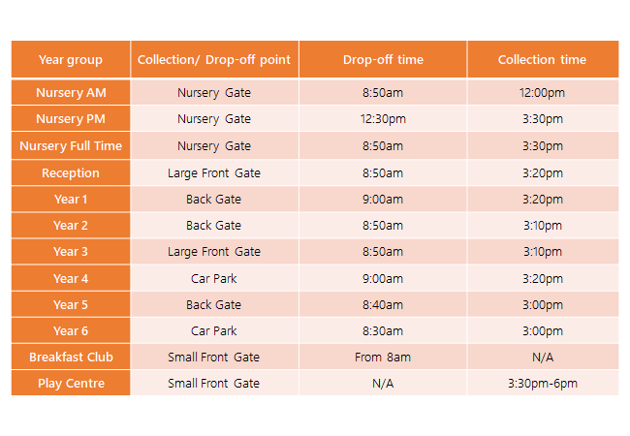
Drop-off and pick-up
The children will be starting at their usual time. I have included a reminder of the times and gates on the chart. This is also on the website. Please ensure that you maintain social distancing at the drop-off and pick-up points each day. If possible please wear a face covering when dropping off or collecting your child.

Breakfast Club and After School Club
Clubs begin again from Monday 8th March. All payment is in advance and children need to be booked in before they can attend. If you would like to book these for your child(ren) please contact the admin team.

Control measures
We have reviewed health and safety risk assessments in light of refreshed guidance. We know that the virus is still here and we must try to prevent the spread by carefully following all of the guidelines.

- If there is a positive case in school, parents will be informed and close
contacts will need to isolate for ten days
- If a member of your household or someone in your support bubble tests
positive then contacts must not attend school for 10 days
- Any child with symptoms should not attend school, if a child presents
with symptoms in school then parents will be contacted to collect them
Children will be reminded to wash and sanitise their hands regularly throughout the school
day. It is not recommended that pupils of primary age wear a mask but we are happy for your child to do so if you so wish.
Morningside staff are testing twice a week to quickly identify any positive cases. Adults in school will be wearing face coverings when they are in communal areas where social distancing is not always possible.

Devices
All laptops, I-pads, 4G routers and Sims that were loaned to families during the lockdown period must now be returned to school in their original boxes. Please ensure that you bring them to the main office by Wednesday 3rd March.

School Streets
Hackney Council have informed us that Morningside School Street will be reinstated from Monday 8 March 2021. The ‘Pedestrian and Cycle Zone’ signs, located at the entrance to the School Street zone, will be reopened and enforcement will recommence from this date.
School Streets work by creating a pedestrian and cycle only zone at school start and finish times. The schemes tackle congestion and improve air quality at the school gates, creating a safer space to walk and cycle to school and enabling social distancing. The School Street at Morningside operates from 8.30-9.30am and 3-4pm on school days only. Vehicles are not permitted to enter the zone between these times unless they have been granted an exemption. If you have already been granted an exemption, you are not required to reapply. To find out more about exemption eligibility, including how to apply for a special exemption, please visit: https://hackney.gov.uk/school-streets

World Book Day
We will be celebrating World Book Day on Thursday 4th March both at home and at school. Children are encouraged to enter our two competitions where they can dress up as a word and/or decorate a potato to look like a character from a book. There are more details and ideas on the website.

If you need support or have any questions please call the admin team. They will pass your queries on to the relevant person who will call you back as soon as possible

Please remember that the lockdown restrictions are still in place -take care, keep well and stay safe.

Yours sincerely

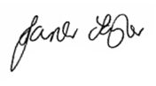

Janet Taylor
Head Teacher

