
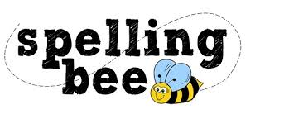

Year One Autumn Term 2020

the | frog
to | cat
and | pig
we | play
she | door
he | day
was | went
shut | sing
flag | box
sheep | school
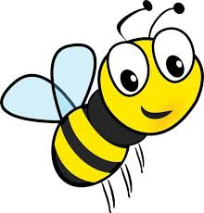 Please practise these spellings if you would like to enter the Morningside Spelling Bee.
Your class teacher will be running heats in your classroom. There is a special certificate for everyone who takes part.
The finals will take place on Tuesday 8th December. Good luck!


