
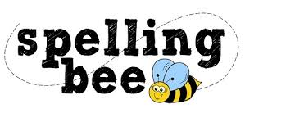

Reception Class Autumn Term 2020
We hope that you will enjoy your first Morningside Spelling Bee
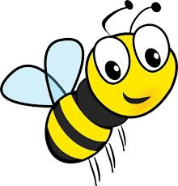
at
in
sad
it
sat
dad
mat
dog
Please practise these spellings if you would like to enter the Morningside Spelling Bee.
Your class teacher will be running heats in your classroom. There is a special certificate for everyone who takes part.
The finals will take place on Tuesday, 8th December. Good luck!


