
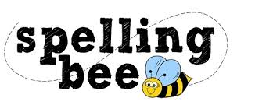

Year One Summer Term 2022

said | some
shop | what
back | have
play | looked
very | could
sing | push
made | asked
about | people

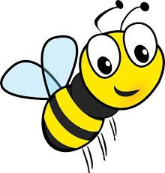Please practise these spellings if you would like to enter the Morningside Spelling Bee. Your class teacher will be running heats in your classroom.
The finals will take place on July 18th. Good luck! 

