
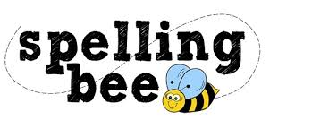

Reception Summer Term 2022

the
and
was
can
mum
look
said
here
one
up
hat
house
play
for
made

 Please practise these spellings if you would like to enter the Morningside Spelling Bee. Your class teacher will be running heats in your classroom.
The finals will take place on Monday 18th July. Good luck! 

