
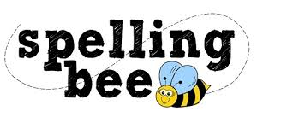

Year One Autumn Term 2022

the | frog
to | cat
and | pig
we | play
she | door
he | day
was | went
shut | sing
flag | box
sheep | school
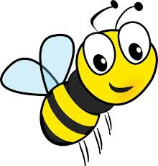 Please practise these spellings if you would like to enter the Morningside Spelling Bee.
Your class teacher will be running heats in your classroom.
The finals will take place on Friday 9th December. Good luck!


