
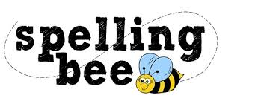

Year Two Autumn Term 2022

floor | come
kind | some
even | Santa
people | money
poor | high
door | night
play | Saturday
today | happy
Monday | new
old | friend
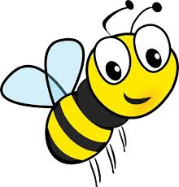Please practise these spellings if you would like to enter the Morningside Spelling Bee. Your class teacher will be running heats in your classroom.
The finals will take place on Friday 9th December. Good luck!


