
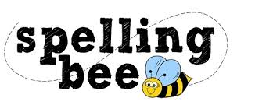

Year One Summer Term

said | some
shop | what
back | have
play | looked
very | could
sing | push
made | asked
about | people

Please practise these spellings if you would like to enter the Morningside Spelling Bee. Your class teacher will be running heats in your classroom.
The finals will take place in the last week of term. Good luck! 

