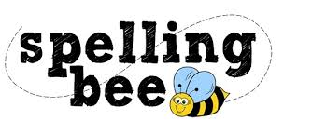


Year Two Summer Term

door | every
pretty | money
behind | half
Wednesday | again
brother | even
grass | who
because | sugar
eye | clothes
people | water
August | eight
 Please practise these spellings if you would like to enter the Morningside Spelling Bee. Your class teacher will be running heats in your classroom.
The finals will take place in the last week of term. Good luck! 

