
Supporting children with BACES: Create a WELLBEING TOOLBOX
We can support children to cover their BACES too. One way of doing this may be to encourage mindful activities or calming breaths. Once you have a few ideas you can create a well-being toolbox!
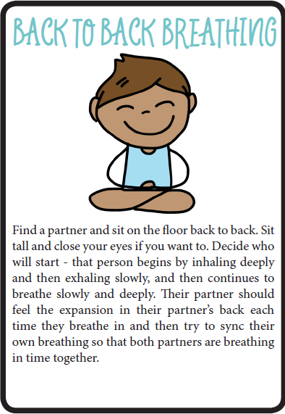
CALMING BREATHS…
STAR BREATHING
Draw me out and use my points to breathe in and out.
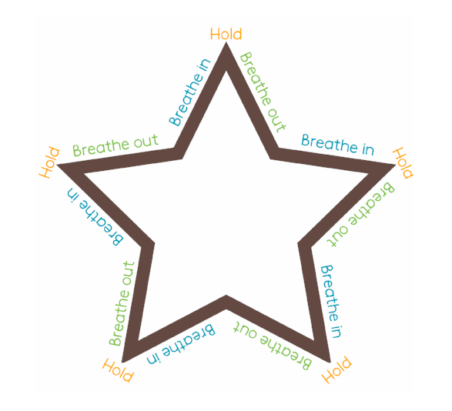

Basic Mindful Walking for Children
Walking outside, particularly where there is nature around, can be the most rewarding.)
1- Have the children stand and take several belly breaths; allowing their bodies to relax from their head to their toes.
2- They are to soften their eyes and fix their gaze on the ground.
3- Tell the children to smile slightly. Smiling signals the brain that what is happening is pleasant.
4- As they walk, have the children focus on the step of each foot as it rises up and then comes back down to the ground.
5- Periodically, have the children stop and notice one object (flower, stone, stick, leaf, etc) or sound (bird chirping, water trickling, car passing, etc) and spend a few moments appreciating that one moment.

