Questions that might be helpful to ask
What are typical childhood worries?
Younger children - fear of the dark, monsters, animals, ghosts, witches, losing their loved ones.
Older children - these worries increase as children notice the world around them e.g. worrying about natural disasters, being more exposed to the news, rejection, danger and social situations.
Other family and community experiences may also be a huge worry for them.
Where to begin?
We’re all different and will respond to things in different ways - let them know that whatever they’re feeling is completely okay. It is crucial to give children positive experiences of telling us how they feel so that they are encouraged to do this more often.
It can be helpful to think about a time when you felt upset and when you spoke to someone - what helped? What didn’t help?
Let children know that what they’re feeling makes sense – try to avoid saying things like “don’t be silly” or “there’s nothing to be worried about” Don’t feel like you need to fix things or have all the answers – lots of things that are happening right now aren’t easy to fix, so instead listen and be available. Let them know that they can come to you with questions, ideas, thoughts and feelings. Give extra cuddles or read an extra story. Let them know that you are there if they need you.

.

I’ve noticed you don’t seem your usual self…

Do you want to talk about it?

It seems like you are feeling…

This sounds really important, I can’t talk about it right now so can we talk about it in 10 minutes/this evening, please?


Containment
Containment is where a person receives and understands the emotional communication of another without being overwhelmed by it then communicates this back to the other person. This process is crucial to avoid children becoming “full up” with difficult emotions.
How do we contain children? Look for clues about their feelings.
Active listening: let them talk without interruption, focus on what is being said, show your interest by nodding and commenting on what is being said
Name what you see or hear from them - they need to know you get it “I can see you’re feeling scared. It is completely understandable. It is a frightening thing to happen.

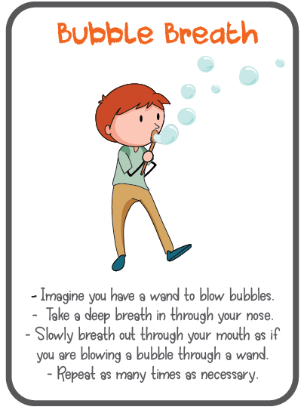
Modelling
Children look up to adults. This is why it is important for us to be their emotional role model:
- Talk about your own emotions
- Share some strategies you use e.g. deep breathing, talking to friends, being creative
- Make these conversations about emotions and feelings a normal conversation
It’s okay to let them know that you are upset or sad for people that are hurting; sharing this with your child will nurture their empathy and compassion – but it is also helpful for them to see your resilience, your capacity to cope with the news and look after your own wellbeing.
If you would like to know more the following book can be a helpful starting point for parents who want to support their child to overcome their worries:
Overcoming Your Child's Fears and Worries: A Self-help Guide Using Cognitive Behavioural Techniques by Cathy Creswell & Lucy Willetts

